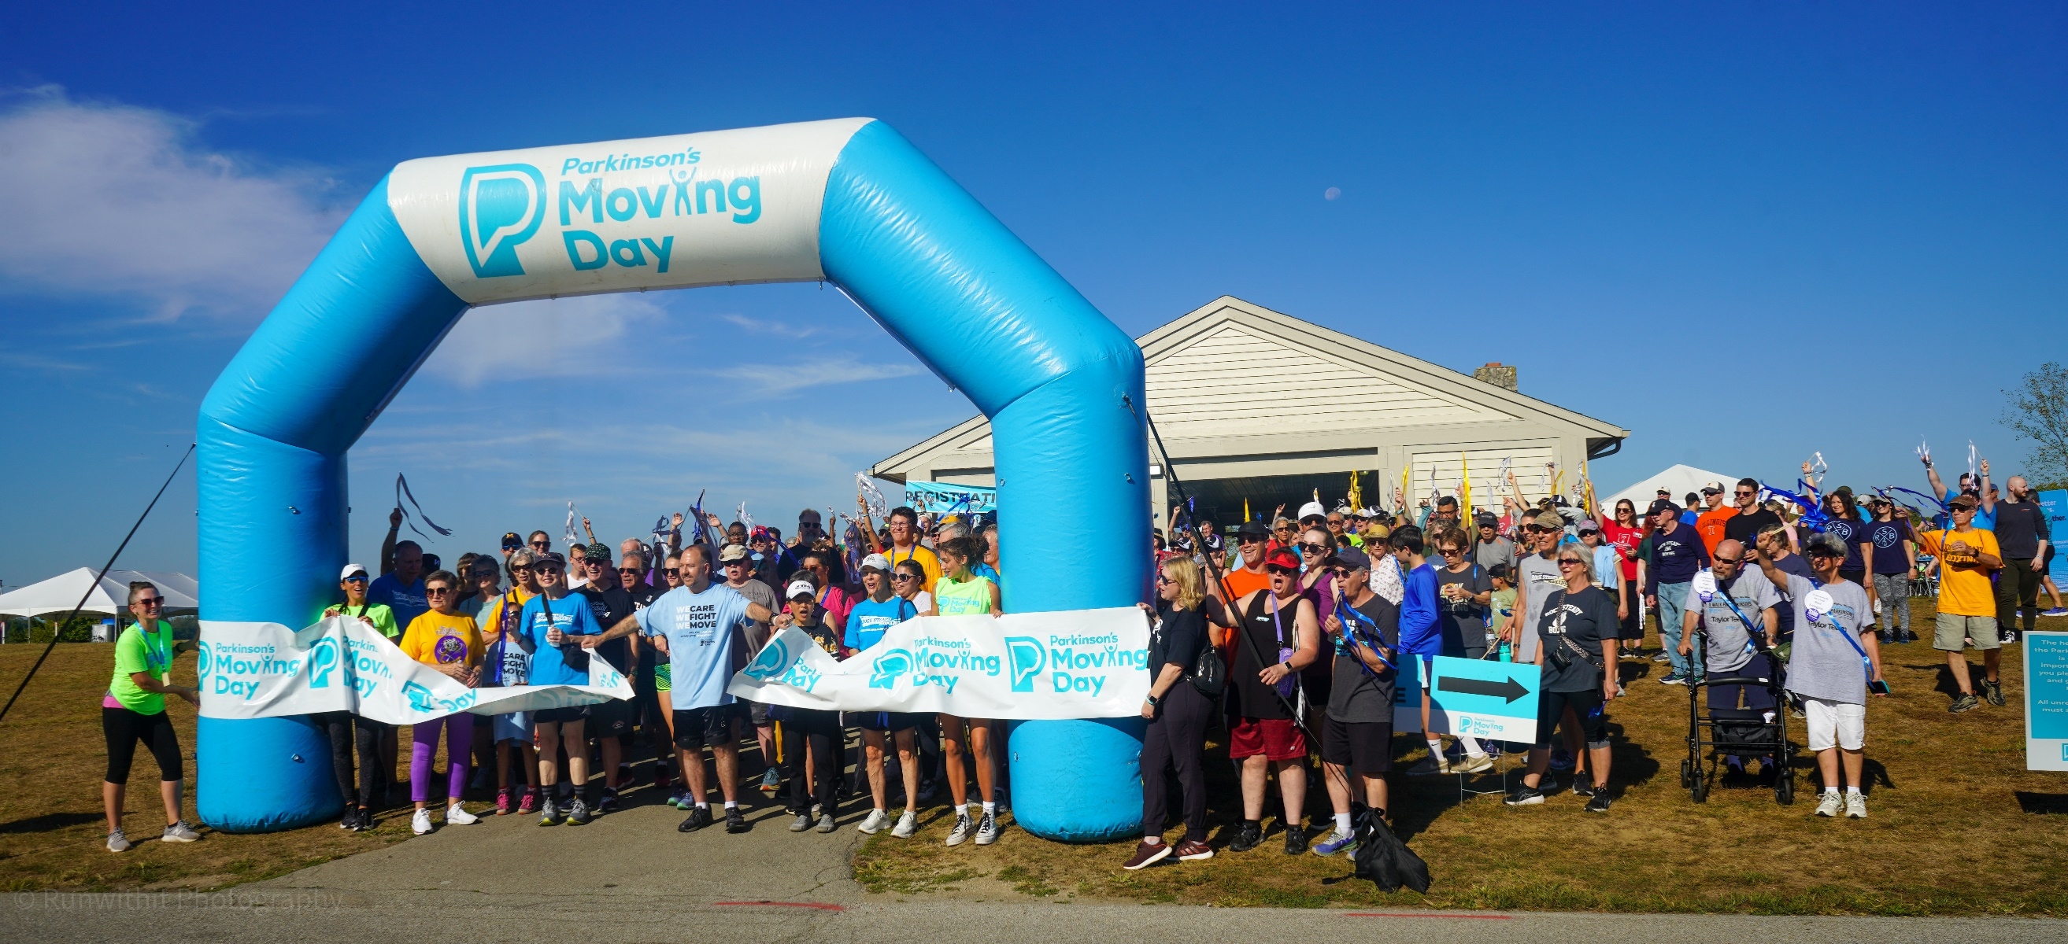

MOVING DAY RICHMOND VA

A Race for the Cure at Richmond International Raceway

SATURDAY, OCTOBER 11, 2025 – 9:30 AM
RICHMOND RACEWAY COMPLEX
600 East Laburnum Avenue, Richmond, VA 23222
MOVINGDAYRICHMONDVA.ORG
Dawn Lewis
Dlewis@PARKINSON.ORG
410-849-6114

THE
FACTS

90,000 new cases are diagnosed each year in the United States.
Prevalence is expected to increase substantially in the next 20 years due to aging of the population.
Second most common neurodegenerative disease after Alzheimer’s.
Nearly one million Americans and ten million worldwide are living with the disease.
Average age of onset is
mid-60’s.
There is no cure for PD, but treatments are available to improve the quality of life.

ABOUT
PARKINSON’S DISEASE
Parkinson’s disease (PD) is the second-most common neurodegenerative disease after Alzheimer’s and is the 14th-leading cause of death in the U.S. It is associated with a progressive loss of motor control (e.g., shaking or tremor at rest and lack of facial expression), as well as non-motor symptoms (e.g., depression and anxiety).
OUR MISSION
The Parkinson’s Foundation makes life better for people with Parkinson’s disease by improving care and advancing research toward a cure. In everything we do, we build on the energy, experience and passion of our global Parkinson’s community.
THE URGENCY
We are the nation’s leading community for people living with Parkinson’s, those who love them and those who are working to end the disease. The 1 million Americans living with PD deserve the promise of a cure and a better life today!

ABOUT
MOVING DAY

Moving Day is an inspiring and empowering annual fundraising
event that has united more than 186,000 participants around
the country living with PD, their care partners and loved ones.
Moving Day is more than just a walk. It is a celebration of
movement – proven to help manage Parkinson’s symptoms.
Moving Day is among the largest Parkinson’s events in the
country and provides excellent brand exposure to thousands of
people in the Parkinson’s community. Funds raised through
Moving Day help:
- Deliver quality care to nearly 200,000 people living with
Parkinson’s.

- Fund cutting-edge research to improve treatments and
advance toward a cure.

- Provide free resources for people living with Parkinson’s and their families.

