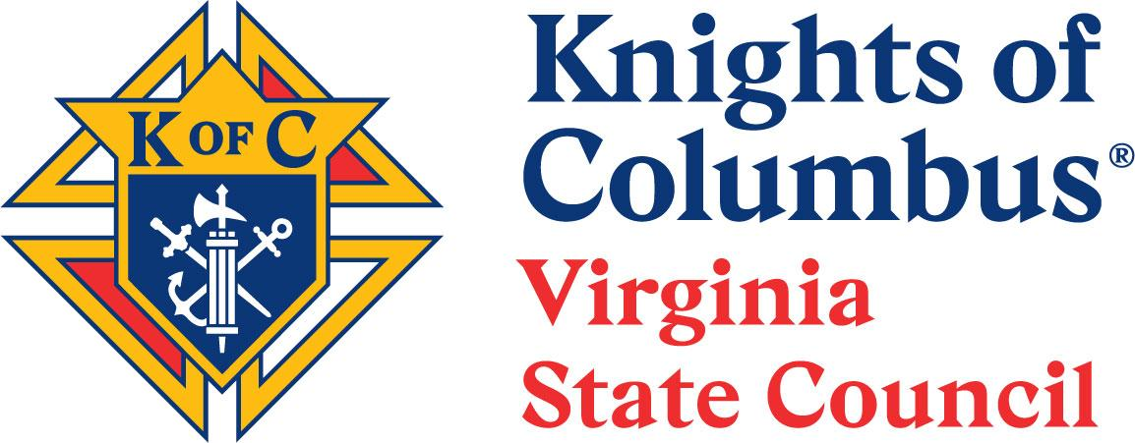

To: State Deputy, State Officers, District Deputies, Grand Knights, Past State Deputies
Members of the Nominating Committee

From: 2025-2026 Nominating Committee Chairman

Subject: Final Report of the 2025-2026 Nominating Committee

Worthy Sirs, the following Slate of Officers is proposed for the Fraternal Year 2026-2027:

State Deputy: John Knox
State Secretary: Ernie Piro
State Treasurer: Anthony Hall
State Advocate: Dan Doyle
State Warden: Steve Bucher

The following names are proposed as Delegates to the 2026 Supreme Convention:
Insurance | Associate
- State Deputy-Elect | - Holland, Barry FDD
- Immediate Past State Deputy | - Grimmig. Alvin FDD
- State Secretary-Elect | - Cormier, Bill FDD
- Rule, Mike – Membership Director | 4. Ripple, Brian PSD
- Beata, Fred- Training Director
- Rose, Scott DD

The following names are proposed as Alternate Delegates to the 2026 Supreme Convention:
Alternate Insurance | Alternate Associate
1. McHugh, James DD | 1. Mortensen, Kelly PSD
2. Scott, Eric DD | 2. Polich, Ed PSD.
3. Szerszynski, Bob PSD | 3. Slowe, Tom DD
4. Moffett, Scott FDD | 4. Pavelchak, Joe DD
Alternates are listed in priority order from top to bottom.

Fraternally,

Patrick Rowland
Patrick A Rowland, PSD
Nominating Committee Chairman

