* Any St. Ann's or St. Mary's parishioner and their dependents are eligible.

* The award winner may attend a:

- Catholic high school, or

- any college or university.

* The criteria for determining awards will include:

- a completed application form

- academic record

- assessment of character based on the letter(s) of recommendation

- a service-oriented work ethic Virgil Hicks would be proud of

-an essay of 500 words maximum on the subject “How my faith guides me in my everyday life”

* Applications are due by **May 15, 2025**.

* Applications should be sent to:

Virgil S. Hicks, Jr. Memorial Scholarship Committee

Knights of Columbus #7538

P.O. Box 2032

Ashland, VA 23005

* Award announcements will be made the end of June 2025.

* Notification of awards will be made by letter to the recipients.

* The disbursement of the award funds shall be by check to the recipient.

* The Scholarship Committee membership and chairman are appointed by the Grand Knight of Council#7538.

* Please forward questions to our Grand Knight: [gk7538@vakofc.org](mailto:gk7538@vakofc.org)

Virgil S. Hicks, Jr. was a founding member of the Joseph M. Johnson council of the Knights of Columbus. He was the Grand Knight in 1987 and active member until he passed away in March, 2008. His family is testimony to his strong belief in getting a good education. In his memory, this scholarship is awarded to children to attend a Catholic high school or any accredited college, university or school.

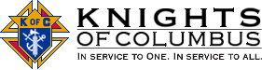

The Joseph M. Johnson Council of the Knights of Columbus was founded in 1980 through the efforts of the men of St. Ann's parish in Ashland and St. Mary of the Annunciation parish in Ladysmith. It is named after Joseph Johnson, who was a tireless volunteer for many worthwhile causes in the parishes.

Thanks to the efforts of Father Michael J. McGivney, assistant pastor of St. Mary’s Church in New Haven and some of his parishioners, the Connecticut state legislature on March 29, 1882, officially chartered the Knights of Columbus as a fraternal benefit society. The Order is still true to its founding principles of charity, unity and fraternity. The Knights was formed to render financial aid to members and their families. Mutual aid and assistance are offered to sick, disabled and needy members and their families. Social and intellectual fellowship is promoted among members and their families through educational, charitable, religious, social welfare, war relief and public relief works.



**VIRGIL S. HICKS, JR. MEMORIAL SCHOLARSHIP**

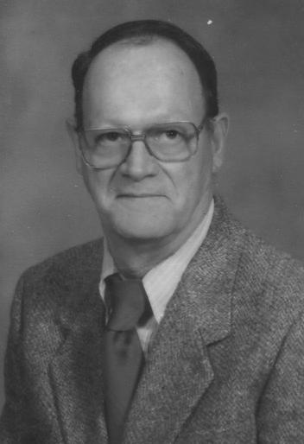

**Knights of Columbus**

**Joseph M. Johnson Council#7538**